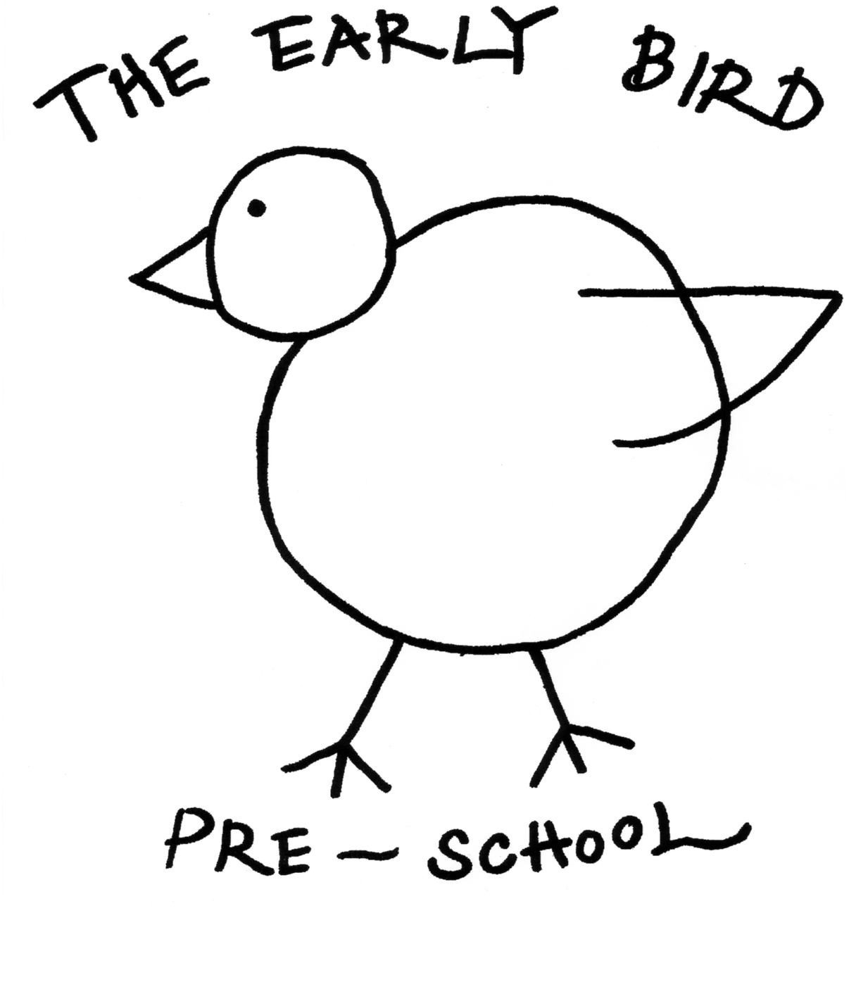The Early Bird Pre-School CIC

Early Years Pupil Premium

Child’s Name ______________________________________

Your child has been identified as being eligible for pupil premium. This is a small amount of money the school will receive each term to support your child’s learning and development. We would like your input to decide how best this can be used to help your child reach their full potential. The sorts of things we can spend the money on is staff training, resources or

|  |  |
| --- | --- |
| Your child’s likes: | Your child’s dislikes/worries: |
|  |  |

|  |  |
| --- | --- |
| Your child’s strengths: | Your child’s areas to develop |
|  |  |

|  |
| --- |
| Action Agreed |
|  |

Signed . . . . . . . . . . . . . . . . . . . . . . . . . . . . . . . . . . (parent/carer)

Signed . . . . . . . . . . . . . . . . . . . . . . . . . . . . . . . . . . (on behalf of setting)

Date . . . . . . . . . . . . . . . . . . . . . . .